String Concatenation Methods in Visual Basic and Paged Buffering

Motivation

There seem to be four basic methods for string concatenation in the Visual Basic world: the quick to code but slow to execute newbie method, the conventional string buffering method, the byte array buffering method, and the temporary file method. Recently I needed to put together some 50K strings fast, and I seem to have a different idea of fast from most everyone else. Of course I knew of the buffering techniques so I simply conducted a day long search of the net, including PSC. I found about twenty snippets of code and classes to do fast string concatenation and began checking under the hood to see if I could squeeze any more speed out of them. I was shocked to see that every bit of code I came across was much slower than it needed to be.

Background

Let me explain what I mean. All the buffering systems I came across (with the exception of the temporary file method which suffers from excessive disk read/write latency) work in the same basic manner. You ask for a string, let’s call it 1000 characters. Now we track our position inside those 1000 characters as we write to our string. When the string is full we ask for a bigger string, say 2000 characters. Next we copy the first 1000 character string into the first 1000 characters of the 2000 character string and then continue to write to the remaining 1000 characters. When we run out of room again, we repeat the process perhaps this time we need 3000 characters though. We’re always asking for bigger and bigger strings and moving around bigger and bigger buffers. “What’s the problem?” you might be asking “how else can you do it?”. I’ll tell you. The answer is what I call paged buffering.

Paged Buffering and Create-On-Demand Pages

The most important thing to understand is there is no good reason why all the bytes of our string need to be in one continuous block of memory (except perhaps that its easy to code and think about). Instead, think of our buffer as an array of separate pages, indeed it is. We ask for a page of 1000 characters and begin filling it up. When we finish filling the page do we get a bigger page and recopy? No way, we just get a new page! We continue to get new pages until we are done constructing our string or we’re out of memory (which is very unlikely). What could be simpler?
This method has two large advantages over other buffering schemes. First and foremost, you don’t waste time moving buffers around in memory, there simply isn’t any need. Second, you no longer ask Windows to find you huge chunks of contiguous memory which is a slow and uncertain endeavor at very large string lengths.
Create-on-demand is nothing more than a “look before you leap” approach to buffer page creation. Asking for a buffer page takes time and if we’ve already created a buffer page from a previous concatenation it makes sense to simply overwrite the existing page. This trick doesn’t make the first concatenation execute any faster but on second and subsequent concatenations it speeds things up about 10%.

Results

Figure 4 below shows the results of medium length strings. Notice that only at very large strings (300,000 characters) does the temporary file method begin to outperform the byte array method. Another interesting thing to note is that at about 40,000 characters the byte array method overtakes the conventional string buffering method. Still, paged buffering is firmly in command.
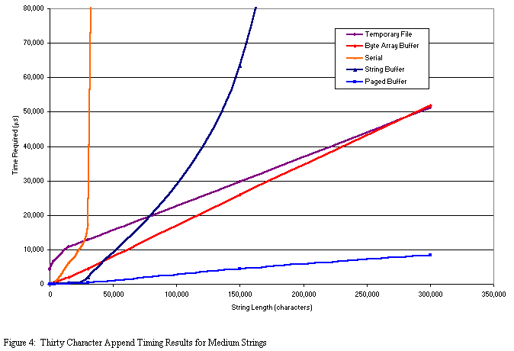

Figure 5 shows the results of very long string concatenation. I’m sure there aren’t many occasions that call for 30 million character strings but should you ever need to make one, you only have two choices, and only one of them is any good, paged buffering. The byte array method has long since bailed out due to “Out of memory” errors. Conventional string buffering would take weeks, and serial concatenation would take years. In actuality both serial and string concatenation would cause “Out of memory” errors as well, but they never get a chance because they are too slow long before they run out of room.

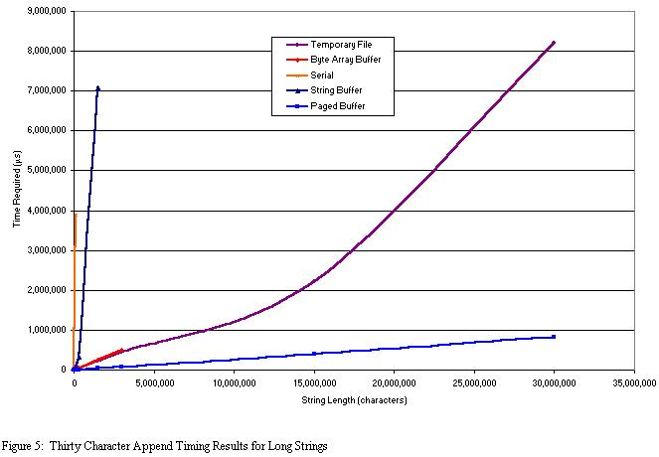
I’ve also included a demonstration project so you can check things out for yourself. The class I’ve written, cFastCat, makes use of paged buffering as well as create-on-demand pages. I’ve also included methods for both emptying the contents of the buffer and releasing all consumed memory. The properties and methods should be pretty self explanatory but if you get lost open up the object browser in the IDE and you can get help on the class. Note that the value of the buffer is the default member, which lets you access the buffer contents the same way you get at the contents of a textbox (strWhatever = Text1).
In order to keep all the buffering methods on equal footing I fixed all the buffer increments at 4096 bytes. In real world applications you can get even better performance out of cFastCat by increasing the buffer page size. I’ve included a property let to make this process easier.

Known Issues

There are two situations in which cFastCat will not perform correctly but neither is really worth addressing. First, if you append a string that is larger than one full buffer page (2000 characters in the default state) the excess could get dropped resulting in an incorrect final result. The easiest solution is to make sure you choose a buffer page size larger than any single append operation. The second known issue is running out of buffer pages. I’m assuming that you’ll know ahead of time about how much space you’ll need and have asked for the correct number of buffer pages. If you do exceed the maximum buffer size the class will cause a run time error and if its compiled will crash the application. Again the easiest fix is to ask for enough room before you begin.
Just to review, both these issues can be avoided entirely by planning on your part.

Conclusion

Paged buffering is quite simply the fastest means of concatenating strings in Visual Basic capable of concatenating 57MB strings in under one second. There are no API calls so cFastCat is exceptionally stable. If you come up with a faster method of concatenating strings I’d like to see it. As always, I welcome your feedback and votes and I hope this helps you.

